_____________________________________________________________________________________________

Corporate identity development brief

The brief is the starting point of our work together. The main purpose of the brief is the identification of unique and specific characteristics that differentiate your company, your product, your market niche and your audience. We want better understand you and your business to find the most effective solution.

Please complete the following brief form and send it to us on e-mail info@abp.biz
E-mail: info@abp.biz
Phone: +1 (415) 800-4570
www.abp.biz

ABP Development Corp.
Registered Office: 244 Hampshire Dr Plainsboro, New Jersey 08536 Certificate Number: 4008248345

Your contact details | Your name:  Your e-mail:  Telephone:  More information:
Describe the essence of the project
You order a logo in the first time? You already have a logo and you want to update or replace it? What you do not like in the old logo? What tasks do you want to solve with the new logo?

Tell us about the brand for which the logo is designed

What is the name of your company? Are there different names? If you have the company's mission and slogan, bring them here. What is the main difference from the competition? What qualities of your brand you want to reflect in the logo?

How to look like your new logo?

The logo can consist of a graphical symbol and text or only one of these elements. If you have any suggestions of what parts should be your new logo, select an option.

If your logo contains text write it.

The font shape  If the logo implies the text part specify the font shape.  Select only one item.  Attachment 1 | Serif  Sans serif
Font plastic  The mood of logo and corporate identity in general depend on the font plastic.  Select only one item.  Attachment 2 | Stable, solid  Dynamic, fast  Flexible, smooth  Joyful, positive  Handwritten  Unusual, modern  Archaic  Classic
Style and form of the graphic symbol  Graphic symbol can be performed in a specific graphic manner. Select the most suitable one.  Select only one item.  Attachment 3 | Graphic elements of the real world  Unique graphic elements (newly formed)  Initial letter as a graphic sign  Clear graphical form  Flexible plastic forms or objects  Abstract graphic elements, fuzzy geometric shapes  Dynamic objects  Monograms  Minimalistic shapes  Multimedia effects (volume, shadows, highlights, gradients)
Elements of corporate style  Do you need more corporate style elements? Select required options for this. | Business card  Letterhead  Mailing envelope  Folder for documents  Write another sections

Target audience

Tell us about the audience you are working with. These are individuals or corporate clients? What are their main geographical, age, social, behavioral signs?

Examples of logos that you like

Bring 3-5 good in your opinion logos. What exactly about them do you consider successful? If there is a logos that you don't like also bring them in.

Colors

Do you have any preferences about the color scheme and other qualities of a logo? If Yes, please describe them.

What data do you have on this project?

What data need to work on the task? Send them to us.

Deadlines and project budget

If the project should be implemented in any concrete terms, specify them. Also, if possible, indicate the budget for the project.

Additional comments

Attachment 1
What is the font shape
The font shape is one of the main characteristic features of the plotting symbols.
It is conditionally possible to divide the fonts on two categories: sans serif and serif.

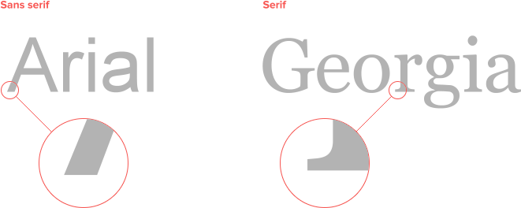

Attachment 2
Font plastic examples

The font plastic is usually described as the nature of the figure formed by the lines and principles of symbols construction.

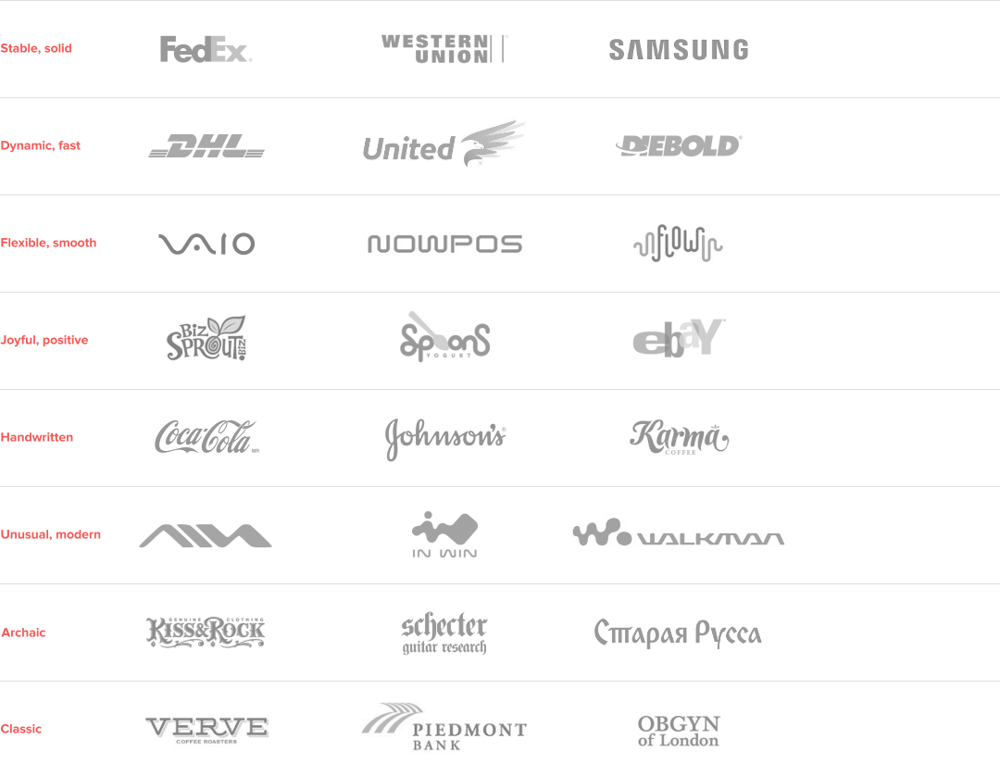

Attachment 3
Graphic symbols styles

The style of the graphical symbol is determined by the shape, plasticity, methods and techniques of its implementation.

